PFG - Aggregation - KT session
DPM AWS Glue job & Step Functions Details
- lambda: create_client_cron_trigger.py
Lambda Function:
br_icsdev_dpmdi_lmbd_create_client_cron_trigger
br_icsqa_dpmdi_lmbd_create_client_cron_trigger
br_icsuat_dpmdi_lmbd_create_client_cron_trigger

This is the Cron job lambda
Git repo: https://git.devops.broadridge.net/ICS-DPM/ics-dpm-di-lambda/-/blob/qa_master/lambda/create_client_c…

Cron will create a trigger file
PFG_ORDER_PROCESSING_20260225204541625.trig

This file will have job names to be queried

First step function is
- br-icsdev-dpmdi-us-east-1-sfn-di-order_grouping_function
- br-icsuat-dpmdi-us-east-1-sfn-di-order_grouping_function

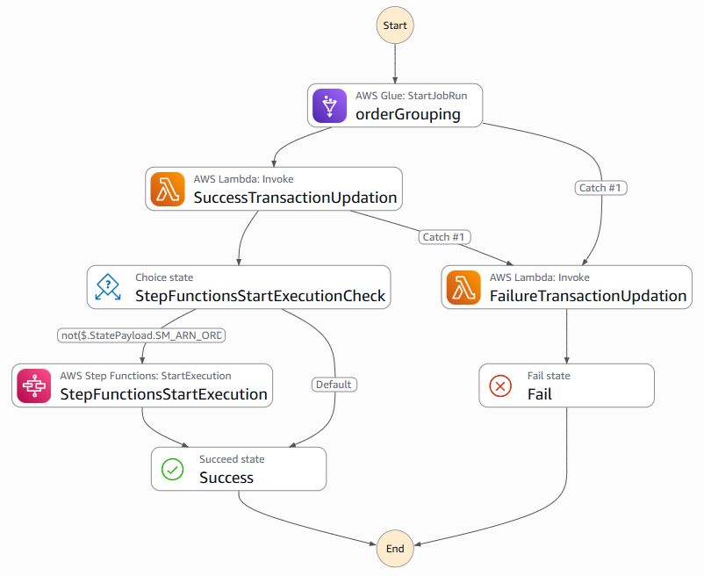

- Code for group orders
- Glue: group_orders.py

https://git.devops.broadridge.net/ICS-DPM/ics-dpm-di-lambda/-/blob/qa_master/glue/group_orders.py?r…

Group orders will create
PFG_CGS72110.n_RETRIEVE_AND_ZIP_02252026151752793.1.trig

Which will kick off second step function
- br-icsdev-dpmdi-us-east-1-sfn-di-orders_data_aggregation
- br-icsuat-dpmdi-us-east-1-sfn-di-orders_data_aggregation

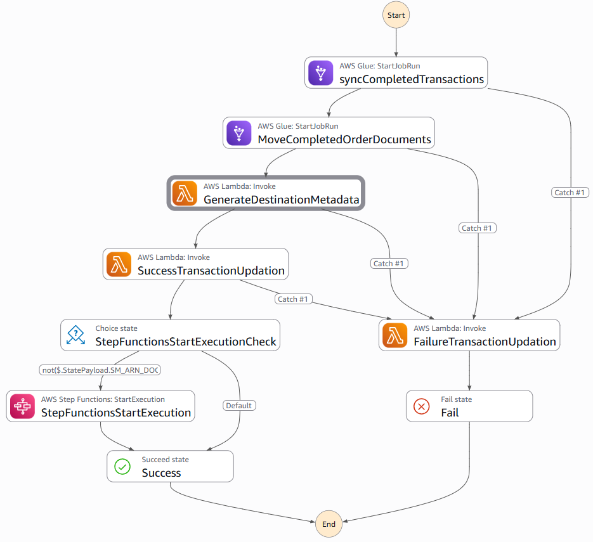
- What is this?
- Glue: send_retrieve_message.py
AWS Glue Job : br_icsdev_dpmdi_glue_send_retrieve_message

First glue job in second step function
https://git.devops.broadridge.net/ICS-DPM/ics-dpm-di-lambda/-/blob/qa_master/glue/send_retrieve_mes…

- What is this?
- Glue: copy_files.py
AWS Glue Job : br_icsdev_dpmdi_glue_copy_files

Second glue job in second step function
https://git.devops.broadridge.net/ICS-DPM/ics-dpm-di-lambda/-/blob/qa_master/glue/copy_files.py?ref…

Step Function:
- br-icsdev-dpmdi-us-east-1-sfn-di-copy_files

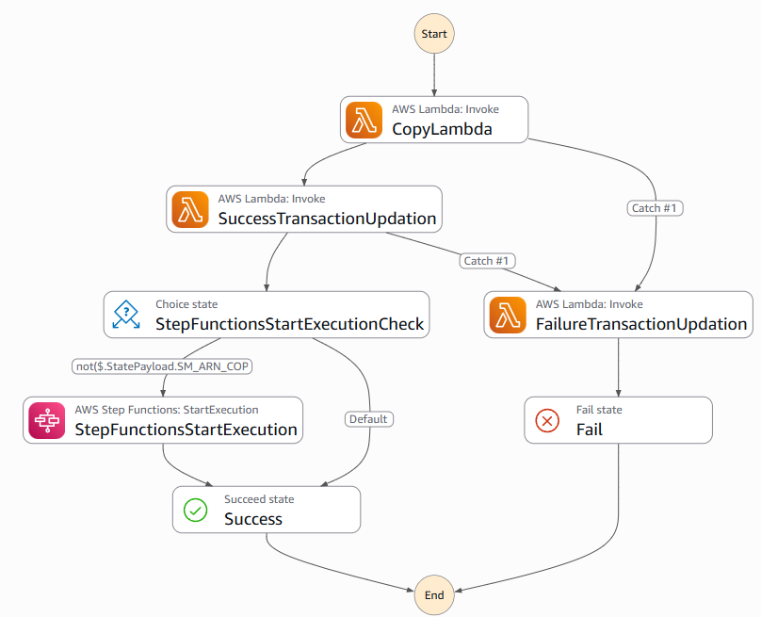

Lambda Function: br_icsdev_dpmpf1_lmbd_copy_files

Post BRX, brx will create a trigger file

PFG_CGS72110.n_RETRIEVE_AND_ZIP_02252026151752793.1.trig.onprem.8ceb2166-0c92-40e1-a159-a64211c88214.brxout

Which will kick off third step function

Compression job will create output file which will kick off next step function

File naming

PFG_PDF2PRINT_20260225151752_CGS72110.n_8ceb2166-0c92-40e1-a159-a64211c88214.tgz

Step function :

br-icsuat-dpmdi-us-east-1-sfn-di-ndmtoonprem

Final step function

br-icsuat-dpmdi-us-east-1-sfn-di-send_order_status_to_ccil

https://git.devops.broadridge.net/ICS-DPM/ics-dpm-di-lambda/-/blob/qa_master/lambda/send_final_stat…

Client configuration table

br_ics_uat_dpmdi_dpm_config_table-0

PFG is key

Cron configuration

key = master_cron_config

https://br.splunkcloud.com/en-US/app/br_itsm/pfgs_order_processing_pipeline_prod

-----------------------------------------------------------------

Recap: PFG - Aggregation - KT session Wednesday, February 25 | Meeting | Microsoft Teams

Transcript. Use arrow keys to navigate between transcript entries. Select an entry to navigate the media to the time of the entry.



Mekala, Dharani
started transcription

Mekala, Dharani
0 minutes 6 seconds0:06
Mekala, Dharani 0 minutes 6 seconds
This is it.

Maiti, Pabitra (CA)
0 minutes 9 seconds0:09
Maiti, Pabitra (CA) 0 minutes 9 seconds
Yes.

Teki, PrasadaRao
0 minutes 10 seconds0:10
Teki, PrasadaRao 0 minutes 10 seconds
Yeah, we can see.

Mekala, Dharani
0 minutes 11 seconds0:11
Mekala, Dharani 0 minutes 11 seconds
OK, so principal, so PFG is principal financial group. So for this we'll get data as orders. Those will come in as XML from client.
Mekala, Dharani 0 minutes 27 seconds
And from client they'll directly come to ESIM enterprise platform, so integrated platform. So they use director server to convert that XML to Jason and push that Jason file to Kafka topics.
Mekala, Dharani 0 minutes 48 seconds
From Kafka topics, Cecil will listen to that. Cecil is a different team. ECIL is a different team. ECIL will convert input XML to Jason. Cecil will take that Jason from Kafka and send it to different teams. So for us.

Maiti, Pabitra (CA)
1 minute 5 seconds1:05
Maiti, Pabitra (CA) 1 minute 5 seconds
OK, so so here now can you do have any CCL flow diagram like this low level design so that like what are the?

Mekala, Dharani
1 minute 5 seconds1:05
Mekala, Dharani 1 minute 5 seconds
Yeah.
Mekala, Dharani 1 minute 14 seconds
No, no. Why? Why we don't? Why we need it? We don't need it. Why do you need it? You only should consider that they're sending us data, how they're implementing, how they design it. We don't care.

Maiti, Pabitra (CA)
1 minute 19 seconds1:19
Maiti, Pabitra (CA) 1 minute 19 seconds
OK.
Mekala, Dharani 3 minutes
So for all these topics, Pabitra implemented this Kafka consumer, so it will take those orders. If it is coming in order table order data, that order data will be stored into order under square table. If it is coming as notification status, it will store it in notification.
Mekala, Dharani 3 minutes 19 seconds
Under retrieve table, both notification will have the actual status. Retrieve table will have extra data like S3 bucket location, everything.
Mekala, Dharani 3 minutes 33 seconds
So this is the Kafka communication process.
Mekala, Dharani 3 minutes 39 seconds
And then comes the actual AWS implementation.
Mekala, Dharani 3 minutes 45 seconds
So have a cron job. So previously it used to be 11:00 EST. Now it is every 30 minutes and we configured which job should run at what time like 11:00. Some jobs will run at 11, some will run it to one, some will run at that.
Mekala, Dharani 4 minutes 2 seconds
1:00 or 2:00. So based on that configuration this Lambda, there is a Lambda called Cron. Let me show that Lambda.

Maiti, Pabitra (CA)
4 minutes 12 seconds4:12
Maiti, Pabitra (CA) 4 minutes 12 seconds
So cron job who who work on that for cron job?

Mekala, Dharani
4 minutes 18 seconds4:18
Mekala, Dharani 4 minutes 18 seconds
It was initially implemented by, I think it was, forgot his name, US.

Maiti, Pabitra (CA)
4 minutes 24 seconds4:24
Maiti, Pabitra (CA) 4 minutes 24 seconds
No, as of now, yeah, only I think he implemented it.

Mekala, Dharani
4 minutes 27 seconds4:27
Mekala, Dharani 4 minutes 27 seconds
Yeah, yeah, Anil, correct. After Anil Vikas, she's making changes into that.

Maiti, Pabitra (CA)
4 minutes 37 seconds4:37
Maiti, Pabitra (CA) 4 minutes 37 seconds
OK, for that con job, do you have any like get code or?

Mekala, Dharani
4 minutes 43 seconds4:43
Mekala, Dharani 4 minutes 43 seconds
Yeah, we held it.

Maiti, Pabitra (CA)
4 minutes 45 seconds4:45
Maiti, Pabitra (CA) 4 minutes 45 seconds
Where it is actually.
Maiti, Pabitra (CA) 4 minutes 50 seconds
Can you open the Git so that it will be more undertable?
Maiti, Pabitra (CA) 5 minutes 9 seconds
So after the one, there are no changes on that con job or?

Mekala, Dharani
5 minutes 13 seconds5:13
Mekala, Dharani 5 minutes 13 seconds
Yeah, because made uh so many changes.

Maiti, Pabitra (CA)
5 minutes 17 seconds5:17
Maiti, Pabitra (CA) 5 minutes 17 seconds
Well, because.

Mekala, Dharani
5 minutes 18 seconds5:18
Mekala, Dharani 5 minutes 18 seconds
Yeah.

Maiti, Pabitra (CA)
5 minutes 19 seconds5:19
Maiti, Pabitra (CA) 5 minutes 19 seconds
OK.
Maiti, Pabitra (CA) 5 minutes 34 seconds
OK, crown job is not a shell script. I thought that the shell script is also Python, right? It is written in Python.

Teki, PrasadaRao
5 minutes 42 seconds5:42
Teki, PrasadaRao 5 minutes 42 seconds
Welcome.

Maiti, Pabitra (CA)
5 minutes 44 seconds5:44
Maiti, Pabitra (CA) 5 minutes 44 seconds
OK.

Mekala, Dharani
5 minutes 46 seconds5:46
Mekala, Dharani 5 minutes 46 seconds
So this one will kick off that connect with database.
Mekala, Dharani 5 minutes 51 seconds
And check for that job if any orders are there.
Mekala, Dharani 5 minutes 55 seconds
If orders are present, it will create a trigger file and put it into S3 bucket.
Mekala, Dharani 6 minutes
For that particular job.
Mekala, Dharani 7 minutes 14 seconds
So once the trigger file is created, this is the step function that gets triggers for that trigger file. First one is grouping.
Mekala, Dharani 7 minutes 24 seconds
So I'll share that sample file I'm here.
Mekala, Dharani 7 minutes 29 seconds
So this silver sample file now.

Teki, PrasadaRao
7 minutes 29 seconds7:29
Teki, PrasadaRao 7 minutes 29 seconds
Uh, let me just uh and come back. Jeff is bringing me on the call.

Mekala, Dharani
7 minutes 32 seconds7:32
Mekala, Dharani 7 minutes 32 seconds
Mm.
Mekala, Dharani 7 minutes 38 seconds
OK, I'm recording the session anyway.

Teki, PrasadaRao
7 minutes 41 seconds7:41
Teki, PrasadaRao 7 minutes 41 seconds
Yeah, yeah.

Mekala, Dharani
7 minutes 48 seconds7:48
Mekala, Dharani 7 minutes 48 seconds
This is the ticket for it. OK, this this one will have.
Mekala, Dharani 8 minutes
It will have job name. It can be comma separated with multiple job names.
Mekala, Dharani 8 minutes 6 seconds
And this one will kick off multiple steps. First one is order grouping. This is a glue job.
Mekala, Dharani 8 minutes 22 seconds
Yeah, my finger.
Mekala, Dharani 8 minutes 28 seconds
So glue job this glue job what it does it will use the job name.
Mekala, Dharani 8 minutes 36 seconds
And query all the orders and there are some business rules like bulk, non bulk, certified, all those logic. So bulk is nothing but which will have address.
Mekala, Dharani 8 minutes 51 seconds
All those orders are called bulk orders without orders are called non bulk. We'll get a bulk non bulk flag in input Jason is bulk flag and within bulk we have subcategory is certified so.
Mekala, Dharani 9 minutes 8 seconds
Because what is the logic for certified?
Mekala, Dharani 9 minutes 13 seconds
I think, uh, some flag is there, right?
KB

Khadka, Bikash
9 minutes 15 seconds9:15
Khadka, Bikash 9 minutes 15 seconds
You.
Khadka, Bikash 9 minutes 17 seconds
The shipping ID for percent by.

Mekala, Dharani
9 minutes 20 seconds9:20
Mekala, Dharani 9 minutes 20 seconds
Shipping ID.
KB

Khadka, Bikash
9 minutes 21 seconds9:21
Khadka, Bikash 9 minutes 21 seconds
4.

Mekala, Dharani
9 minutes 23 seconds9:23
Mekala, Dharani 9 minutes 23 seconds
OK, shipping ID if it is 4 then it will be certified well and apart from that bulk loose bulk loose also bulk loose is only for few job names. So currently those are configured in this one client config JSOM.
Mekala, Dharani 9 minutes 39 seconds
So only those job names will go to bulk loose. So for bulk OK there is a condition called grouping. All orders belong to same, all orders belonging to same orders.
Mekala, Dharani 9 minutes 55 seconds
Should be grouped as a single output JSON so that applies for bulk loose.
10:02
10 minutes 2 seconds
Yes.

Mekala, Dharani
10 minutes 4 seconds10:04
Mekala, Dharani 10 minutes 4 seconds
So all the conditions are here. Based on that conditions, it will update the order table with the parent ID and create an output file.
Mekala, Dharani 10 minutes 16 seconds
It will have all the order data order Jason dumped into that input file.
Mekala, Dharani 10 minutes 21 seconds
So remaining all our normal steps access failure and this one will kick off the next step function.
Mekala, Dharani 10 minutes 41 seconds
This one is actually removed. I don't think it's needed, but I'll let it be. This one will create one input file which will kick off the next step.
Mekala, Dharani 10 minutes 52 seconds
We bring the step function name here.
Mekala, Dharani 11 minutes 23 seconds
And that the glue job code is here glue glue glue glue glue.
Mekala, Dharani 11 minutes 47 seconds
This is the code.
Mekala, Dharani 11 minutes 50 seconds
Next step function is uh.
Mekala, Dharani 11 minutes 54 seconds
Order aggregation.
Mekala, Dharani 12 minutes 10 seconds
So that group orders will create this input file.
Mekala, Dharani 12 minutes 31 seconds
So then I'll call this a second step function. This is data aggregation.
Mekala, Dharani 12 minutes 42 seconds
Yep, So what this does is it will have two steps. One is the sync completed transactions. So it will open that input file, get all the order JSONS, pull order IDs and Add all those order IDs into a transaction table order transactions.
Mekala, Dharani 12 minutes 58 seconds
And if any of the orders, it will also check for S3 location for every order. If any S3 location is missing, it will send a message to retrieve topic.
Mekala, Dharani 13 minutes 15 seconds
The next glue job is more completed order document. So what it does is it will connect with order transactions table, pull all the order IDs and get the Astro location for all those orders, then copies those PDF files from Astro location to our.
Mekala, Dharani 13 minutes 33 seconds
Uh, local S3 bucket.

Maiti, Pabitra (CA)
13 minutes 42 seconds13:42
Maiti, Pabitra (CA) 13 minutes 42 seconds
If the let's consider S3 bucket is not present or somehow got deleted, right? Existing S3 bucket. So then what would happen here?

Mekala, Dharani
13 minutes 53 seconds13:53
Mekala, Dharani 13 minutes 53 seconds
We're doing here a test checking right here. S3 bucket is there or not. If that S3 bucket is not there then we'll send a retry message and it is responsibility of CSL to create that bucket again. If even after this it's not able to create then we fail that.
Mekala, Dharani 14 minutes 11 seconds
On a job.

Maiti, Pabitra (CA)
14 minutes 13 seconds14:13
Maiti, Pabitra (CA) 14 minutes 13 seconds
OK, are you checking the S3 bucket or uh that uh files you are checking which is?

Mekala, Dharani
14 minutes 17 seconds14:17
Mekala, Dharani 14 minutes 17 seconds
File in the test relocation.

Maiti, Pabitra (CA)
14 minutes 21 seconds14:21
Maiti, Pabitra (CA) 14 minutes 21 seconds
OK.

Mekala, Dharani
14 minutes 24 seconds14:24
Mekala, Dharani 14 minutes 24 seconds
So this one next step will think that all S3 locations are present. If any of them is missing, it will fail.
Mekala, Dharani 14 minutes 35 seconds
It will fail only that order. Remaining orders will continue.

Maiti, Pabitra (CA)
14 minutes 35 seconds14:35
Maiti, Pabitra (CA) 14 minutes 35 seconds
OK.

Mekala, Dharani
14 minutes 43 seconds14:43
Mekala, Dharani 14 minutes 43 seconds
This one we removed it, but it's still there. We can ignore it.
Mekala, Dharani 14 minutes 51 seconds
Oh, sorry.
Mekala, Dharani 14 minutes 53 seconds
So this what this one does is it will create a trigger file for BRX director server BRX so it will create a metadata file.

